CODE:
#NumPy Arrays
import numpy as np
a = np.array([1, 2, 3])
b = np.array([[4, 5], [6, 7]])
print("1D Array:", a)
print("2D Array:\n", b)
OUTPUT:
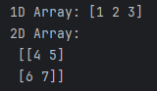

CODE:
#Array Attributes
import numpy as np
a = np.array([1, 2, 3])
b = np.array([[4, 5], [6, 7]])
print("Shape:", b.shape)
print("Datatype:", b.dtype)
print("Size:", b.size)
OUTPUT:
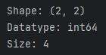

CODE:
#Array Operations
import numpy as np
x = np.array([10, 20, 30])
y = np.array([1, 2, 3])
print("Addition:", x + y)
print("Multiplication:", x * y)
print("Sqrt:", np.sqrt(x))

OUTPUT:
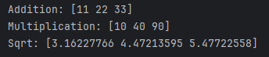
CODE:
#NumPy Advanced Operations
#arange, reshape
import numpy as np
arr = np.arange(0, 10, 2)
reshaped = arr.reshape(1, 5)
print("Arange:", arr)
print("Reshaped:", reshaped)

#Boolean Indexing
data = np.array([10, 15, 20, 25, 30])
print("Greater than 20:", data[data > 20])

#Random Numbers
np.random.seed(0)
print("Random Integer:", np.random.randint(1, 100, size=(2, 3)))

OUTPUT:
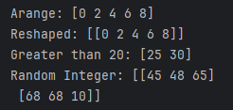

CODE:
#Arrays Using zeros(), ones(), eye()
import numpy as np
a = np.zeros((2, 3))
b = np.ones((3, 3))
c = np.eye(4) # Identity matrix
print("Zeros:\n", a)
print("Ones:\n", b)
print("Identity Matrix:\n", c)

OUTPUT:
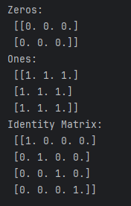

CODE:
#Array Reshaping and Flattening
import numpy as np
arr = np.arange(12) # [0 to 11]
reshaped = arr.reshape(3, 4)
flattened = reshaped.flatten()
print("Reshaped Array:\n", reshaped)
print("Flattened Array:", flattened)
OUTPUT:
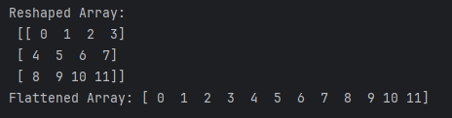

CODE:
# Matrix Multiplication
import numpy as np
A = np.array([[1, 2], [3, 4]])
B = np.array([[5, 6], [7, 8]])
result = np.dot(A, B)
print("Matrix A:\n", A)
print("Matrix B:\n", B)
print("Dot Product (A x B):\n", result)
OUTPUT:
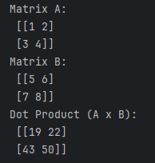
CODE:
# Broadcasting Example
import numpy as np
a = np.array([[1], [2], [3]])
b = np.array([10, 20, 30])
result = a + b
print("Broadcasted Addition:\n", result)
OUTPUT:
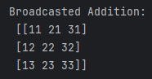

CODE:
# Statistical Operations
import numpy as np
data = np.array([10, 20, 30, 40, 50])
print("Mean:", np.mean(data))
print("Median:", np.median(data))
print("Standard Deviation:", np.std(data))
print("Variance:", np.var(data))
OUTPUT:
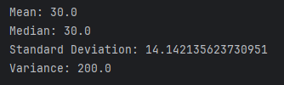
CODE:
# Using where() to Filter or Replace Data
import numpy as np
arr = np.array([5, 15, 25, 35, 45])
filtered = np.where(arr > 20, "High", "Low")
print("Original Array:", arr)
print("Labels:", filtered)
OUTPUT:
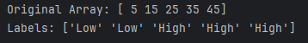
CODE:
# Sorting and Searching
import numpy as np
arr = np.array([50, 10, 20, 40, 30])
sorted_arr = np.sort(arr)
index = np.where(arr == 40)
print("Sorted:", sorted_arr)
print("Index of 40:", index[0])
OUTPUT:
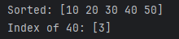
CODE:
# Random Sampling and Distributions
import numpy as np
np.random.seed(0)
rand_arr = np.random.rand(3, 3) # Uniform distribution [0, 1)
normal_arr = np.random.randn(3, 3) # Standard normal distribution
print("Random Uniform Array:\n", rand_arr)
print("Random Normal Array:\n", normal_arr)

OUTPUT:
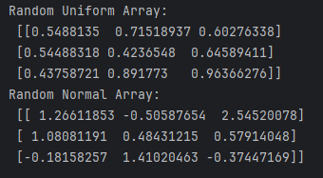

CODE:
# Set Operations in NumPy
import numpy as np
a = np.array([1, 2, 3, 4])
b = np.array([3, 4, 5, 6])
print("Union:", np.union1d(a, b))
print("Intersection:", np.intersect1d(a, b))
print("Set Difference:", np.setdiff1d(a, b))
OUTPUT:
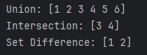

CODE:
# Apply Universal Functions (ufuncs)
import numpy as np
x = np.array([0, np.pi/2, np.pi])
print("Sine:", np.sin(x))
print("Cosine:", np.cos(x))
print("Exponential:", np.exp(x))
print("Logarithm:", np.log([1, np.e, np.e**2]))
OUTPUT:
